FINAL PROJECT DOCUMENTATION
Online Learning Engagement and Student Performance Analysis
Power BI Analytics Project

Table of Contents
1. Introduction
1.1. Project overviews
1.2. Objectives
2. Project Initialization and Planning Phase
2.1. Define Problem Statement
2.2. Project Proposal (Proposed Solution)
2.3. Initial Project Planning
3. Data Collection and Preprocessing Phase
3.1. Data Collection Plan and Raw Data Sources Identified
3.2. Data Quality Report
3.3. Data Exploration and Preprocessing
4. Data Visualization
4.1. Framing Business Questions
4.2. Developing Visualizations
5. Dashboard
5.1. Dashboard Design Screenshot with Insights
6. Report
6.1. Report Design Screenshot with Insights
7. Performance Testing
7.1 Utilization of Data filters
7.2 No of Calculation Columns/Measures
7.3 No of Visualization
8. Conclusion/Observation
9. Future Scope
10. Appendix
10.1. Source Code
10.2. GitHub & Project Demo Link

1. Introduction

1.1. Project Overview
Online Learning Engagement and Student Performance Analysis is a Power BI analytics project designed to understand student demographics, engagement, academic performance, risk level, dropout status, and final course outcomes. The supplied project documentation defines the objective as transforming raw student data into understandable insights for academic monitoring and data-driven decision-making. The solution combines data preparation, SQL-based analysis, Power Query transformations, data modeling, and interactive Power BI reporting.

1.2. Objectives
• Analyze how online-learning engagement indicators relate to student performance.
• Summarize student outcomes using average score, pass rate, dropout rate, engagement level, performance level, risk level, and final result.
• Compare student patterns across region, gender, highest education, and other available dimensions.
• Clean and standardize the supplied online-education dataset before reporting.
• Provide interactive Power BI dashboards with filters and visual summaries for analysis.

Project at a Glance
Component | Provided Project Detail
Project name | Online Learning Engagement and Student Performance Analysis
Primary platform | Power BI Desktop
Database / SQL tool | MySQL / SQL Server compatible environment; MySQL Workbench / SSMS
Raw source | online_education_dataset.csv
Raw size | 32,593 records × 14 fields; 3.10 MB
PBIX | Dataset(1).pbix
SQL file | Query.sql

2. Project Initialization and Planning Phase

2.1. Define Problem Statement

Problem Statement 1: Monitoring engagement, performance, and dropout
Educational institutions and online learning platforms need to understand student engagement, academic performance, and dropout patterns. The supplied problem-statement template notes that raw data contains engagement level, total clicks, academic results, education background, and region, but these factors are not always easy to interpret together. As a result, it can be difficult to identify groups that may need additional support and to make timely, data-driven decisions for student success and retention.

Problem Statement 2: Comparing outcomes across student groups
The second problem statement focuses on comparing performance, engagement, pass rates, and dropout rates across regions, educational backgrounds, engagement levels, risk levels, and final results. The project addresses this by building grouped and filtered views in Power BI so that patterns in the raw student-level data can be explored more clearly.

2.2. Project Proposal (Proposed Solution)
The proposed solution follows a structured data-analysis workflow: collect or import the student dataset, store or manage data using a compatible SQL database, clean and prepare the data, perform SQL-based analysis, connect the prepared dataset to Power BI, create charts and dashboards, and interpret the resulting patterns. The supplied proposal also defines the use of SQL filtering, aggregation, and querying together with interactive Power BI dashboards.

System and Resource Requirements
Resource | Specification
Operating System | Windows 10 or Windows 11 (64-bit)
Processor | Intel Core i3 / AMD Ryzen 3 or higher
RAM | Minimum 8 GB
Storage | At least 5 GB free space
Display | 1366 × 768 resolution or higher
Database | MySQL / SQL Server or compatible SQL database
SQL Tool | MySQL Workbench / SQL Server Management Studio
Visualization | Power BI Desktop (latest version recommended)

2.3. Initial Project Planning
The supplied sprint plan organizes the work into three sprints. The planned backlog contains ten user stories with point estimates totaling 19 story points. Sprint 1 covers data understanding, data cleaning, and data preparation; Sprint 2 covers performance, engagement, and final-result analysis; Sprint 3 covers risk, dropout, demographic analysis, and dashboard development.
Sprint | User Story | Planned Work | Points | Priority
Sprint 1 | USN-1 | Understand dataset and important student fields | 2 | High
Sprint 1 | USN-2 | Clean and prepare student data | 2 | High
Sprint 1 | USN-3 | Prepare required fields and measures | 2 | High
Sprint 2 | USN-4 | Student performance analysis | 2 | High
Sprint 2 | USN-5 | Student engagement analysis | 2 | High
Sprint 2 | USN-6 | Final result analysis | 2 | Medium
Sprint 3 | USN-7 | Risk analysis | 2 | High
Sprint 3 | USN-8 | Dropout analysis | 2 | High
Sprint 3 | USN-9 | Demographic analysis | 1 | Medium
Sprint 3 | USN-10 | Power BI dashboard development | 2 | High

3. Data Collection and Preprocessing Phase

3.1. Data Collection Plan and Raw Data Sources Identified
The project uses the provided CSV file online_education_dataset.csv as the raw source. The data-collection plan states that the file is imported into Power BI, then reviewed, cleaned, transformed, and modeled before report creation. The supplied raw-source report identifies the file as a 3.10 MB private local CSV containing 32,593 records and 14 fields covering demographics, education, engagement, performance, risk, and final outcomes.
Source | Description | Format | Size
online_education_dataset.csv | Online education student dataset covering demographics, education, engagement, performance, risk, and outcomes | CSV | 3.10 MB

3.2. Data Quality Report
Issue | Severity | Evidence | Resolution / Handling
Missing values | High | Missing values were identified in IMD_band, Total_clicks, avg_score, engagement_level, performance_level, and risk_level. | Use Unknown for missing IMD_band; keep avg_score null where no assessment score exists; use Not Available for missing categorical values; use 0 for missing Total_clicks.
Exact duplicates | High | 1,356 exact duplicate rows were identified. | Remove only exact duplicate rows across all columns. Repeated id_student values are retained because a student can have multiple records.
Inconsistent IMD format | Moderate | An IMD value such as 10-20 appeared without the percentage sign. | Standardize to 10-20% and apply consistent text formatting.
Numeric / binary validation | Moderate | Numeric fields and binary flags require validation. | Store studied_credits, pass_flag, and dropout_flag as whole numbers; store total_clicks and avg_score as numeric values; validate ranges and flag values.

3.3. Data Exploration and Preprocessing

Data Overview
The source dataset contains 32,593 records and 14 columns. The project documentation identifies fields for student ID, gender, region, education level, study credits, IMD band, total clicks, average score, engagement level, performance level, risk level, pass flag, dropout flag, and final result.

Cleaning and Standardization
• 1,356 exact duplicate rows were identified and removed.
• Repeated id_student values were retained rather than treated as duplicates by themselves.
• Text fields were trimmed and standardized for region, education level, engagement level, performance level, and risk level.
• Blank values were converted to null values during preparation.
• Numeric columns such as studied credits, total clicks, and average score were checked for invalid or unusual values.
• Missing average scores were retained as null when no assessment score was recorded.

Data Transformation
• The IMD_band field was standardized; an inconsistent value such as 10-20 was corrected to 10-20%.
• Dimensions used in reporting include gender, region, engagement level, performance level, risk level, final result, and highest education.
• Measures were prepared for student counts, scores, clicks, pass rate, and dropout rate.
• IMD_band was split on the hyphen into lower and upper bounds for numeric analysis; the display label was preserved.

Data Type Conversion
Categorical dimensions such as gender, region, engagement level, performance level, risk level, final result, and education are treated as text. Numeric measures such as total clicks and average score are treated as numeric values. Correct data types support calculations, filtering, sorting, and charting.

Data Modeling
The cleaned dataset is loaded into Power BI as the main fact table. A unique index column is added to identify each record, and separate dimension tables are described for gender, region, education level, IMD band, engagement level, performance level, and risk level. Relationships are established between the dimension tables and the main fact table to support consistent filtering and reporting.

Processed Data Output
After the Power Query steps are applied, the prepared table is loaded into the Power BI model. The PBIX file preserves the transformations, data model, measures, and report visuals for subsequent analysis.

4. Data Visualization

4.1. Framing Business Questions
No. | Business Question | Used Visual | Key Fields
1 | Which regions have the highest average student scores? | Horizontal bar chart | Region + Average Score
2 | What is the distribution of total students by engagement level? | Pie chart | Engagement level + Total Students
3 | How are students distributed across final results? | Column chart | Final result + Total Students
4 | How does average number of clicks vary across engagement levels? | Column chart | Engagement level + Average Clicks
5 | What is the relationship between engagement level and final student results? | Matrix / hierarchical bar | Engagement level + Final result
6 | How does dropout rate vary by highest education level? | Column chart | Highest education + Dropout Rate
7 | What is the distribution of students by risk level? | Pie chart | Risk level + Students
8 | How do pass rate and final-result counts differ by gender and education level? | Bar charts | Gender / Highest education + outcomes

4.2. Developing Visualizations
The supplied PBIX report definition contains two report pages. The report uses KPI cards, column charts, a donut chart, a pie chart, slicers, and text boxes. The visual design follows a blue-themed layout with KPI cards along the top and analysis visuals below, while filter controls are placed on the right side of the analytics page.
Visual Type | Count | Purpose
Card visuals | 5 | Total Students, Dropout Rate, Average Score, Average Clicks, Pass Rate
Card visuals | 5 | KPI summaries repeated for the analytical report page
Slicers | 6 | Gender, Region, Engagement Level, Performance Level, Risk Level, Final Result
Column charts | 3 | Region student totals; Average Clicks by Engagement; Average Score by Engagement
Donut chart | 1 | Total Students by Final Result
Pie chart | 1 | Average Score by Performance Level
Text boxes | 3 | Dashboard title / text elements

Across the supplied PBIX report definition, 24 visuals are present: 10 card visuals, 6 slicers, 3 text boxes, 3 column charts, 1 donut chart, and 1 pie chart.

Core Measures Identified in the Report
Measure | Purpose
Total Students | Distinct student count used for KPI cards and categorical comparisons
Average Score | Average academic score used in KPI and performance comparisons
Average Clicks | Average total clicks used as an engagement indicator
Dropout Rate | Share of records marked with dropout_flag used for retention analysis
Pass Rate | Share of records marked with pass_flag used for outcome analysis

5. Dashboard

5.1. Dashboard Design Screenshot with Insights
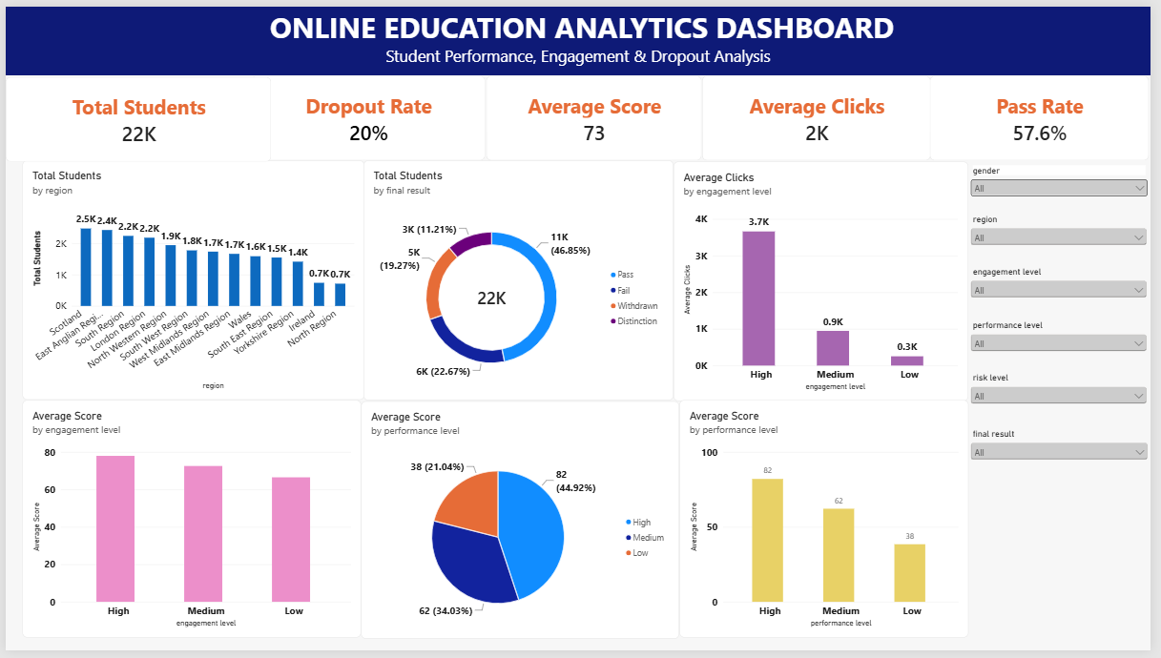
Figure 5.1. Online Education Analytics Dashboard – Student Performance, Engagement & Dropout Analysis

Dashboard Insights
• The dashboard reports approximately 22K students; the report design documentation gives the exact total as 22,422 distinct students.
• The KPI section reports a dropout rate of 20%, an average score of 73, an average clicks value displayed around 2K, and a pass rate of 57.6%. The dashboard design notes the average clicks more precisely as approximately 1.76K, with the KPI card rounded to 2K.
• The final-result donut shows Pass as the largest category, followed by Fail, Withdrawn, and Distinction.
• Average clicks are highest for the High engagement group, then Medium, then Low; the engagement chart in the supplied dashboard is consistent with engagement being strongly differentiated by click activity.
• Average score is highest for the High performance category, followed by Medium and Low performance.
• The slicers allow users to filter the dashboard by gender, region, engagement level, performance level, risk level, and final result.

6. Report

6.1. Report Design Screenshot with Insights
The project report contains two major analytical views: a student performance and engagement overview, and a risk, dropout, and demographic analysis page.
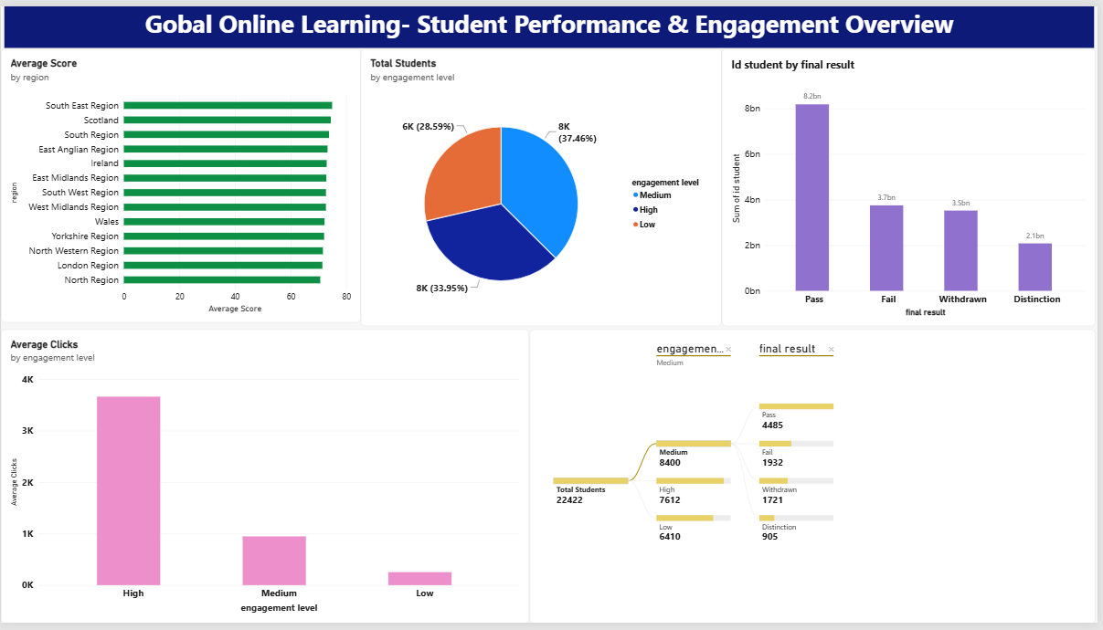
Figure 6.1. Global Online Learning – Student Performance & Engagement Overview
• Average scores across regions are mostly in the 70s, enabling region-to-region comparison.
• Engagement is separated into High, Medium, and Low; the High engagement group has the highest average clicks.
• The overall student total is 22,422 in the supplied report design.
• The final-result view groups students into Pass, Fail, Withdrawn, and Distinction, with Pass as the largest overall result category.
• A hierarchical view can be used to inspect final outcomes after selecting an engagement level.

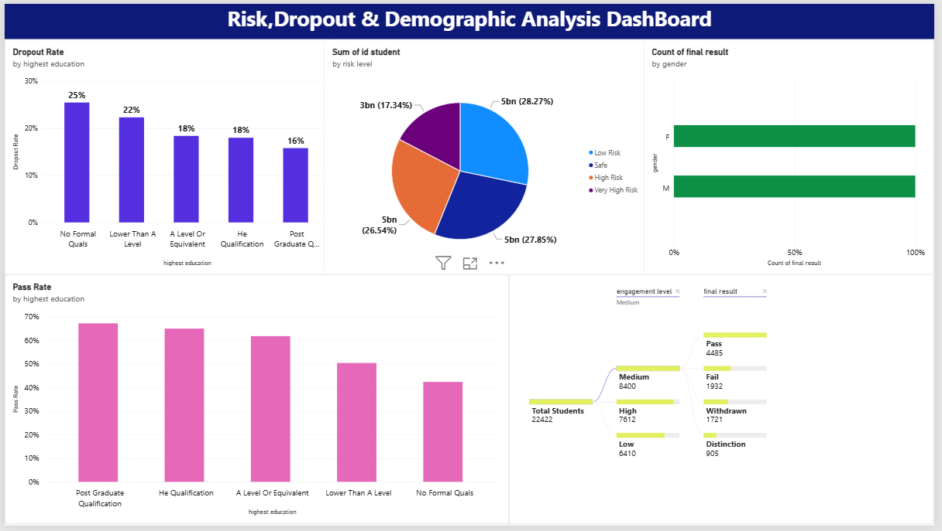
Figure 6.2. Risk, Dropout & Demographic Analysis Dashboard
• The report compares four risk categories: Low Risk, Safe, High Risk, and Very High Risk.
• Dropout rate varies by highest education level; the supplied report shows the highest visible rate for No Formal Qualifications and the lowest visible rate for Post Graduate Qualification.
• Pass rate also varies by highest education level; the supplied report shows the highest visible pass rate for Post Graduate Qualification and the lowest for No Formal Qualifications.
• Demographic views compare the student population by gender and region and allow final-result comparisons across gender groups.

7. Performance Testing

7.1. Utilization of Data Filters
The main analytics page uses six slicers. Each slicer is implemented as a dropdown in the supplied PBIX report definition and is intended to filter the report visuals interactively.
Filter / Slicer | Purpose
Gender | Compare outcomes by gender
Region | Focus the analysis on specific regions
Engagement Level | Filter High, Medium, or Low engagement students
Performance Level | Filter High, Medium, or Low performance students
Risk Level | Filter Low Risk, Safe, High Risk, or Very High Risk
Final Result | Filter Pass, Fail, Withdrawn, or Distinction

7.2. Number of Calculation Columns / Measures
Five core report measures are identifiable in the supplied PBIX report definition: Total Students, Average Score, Average Clicks, Dropout Rate, and Pass Rate. The preprocessing documentation additionally states that a unique index column was added to identify each record. A separate calculation-column count is not explicitly exposed in the supplied report documentation, so no additional number is asserted here.

7.3. Number of Visualizations
Visual Element | Count
Card visuals / KPI cards | 10
Slicers | 6
Column charts | 3
Donut chart | 1
Pie chart | 1
Text boxes | 3
Total visuals across supplied PBIX definition | 24

The two-page PBIX model therefore contains a compact KPI page and a more detailed interactive analytics page. The distribution of visuals is aligned with the supplied dashboard design documents.

8. Conclusion / Observation
The completed project demonstrates a full analytics workflow from raw student data to an interactive Power BI report. The supplied source contains 32,593 records across 14 fields and requires cleaning for duplicates, missing values, inconsistent formats, and numeric validation before reporting. The project then uses SQL queries and Power BI measures to summarize student counts, scores, clicks, pass outcomes, and dropout outcomes.
The resulting visuals make several patterns easy to observe: High engagement is associated with the highest average click activity; average scores differ across engagement and performance levels; Pass is the largest final-result category; dropout rate varies across education groups; and risk levels can be compared interactively. These observations are descriptive findings from the supplied dataset and project report, not causal conclusions.
From a project-delivery perspective, the PBIX report includes 24 defined visuals and 6 interactive slicers, supported by 5 core measures. The combination of data preparation, SQL analysis, and Power BI visualization provides a practical analytical solution for monitoring online learning engagement and student performance.

Key Observations Summary
Area | Observation
Student population | 22,422 distinct students are reported in the supplied Power BI report design.
Engagement | High engagement has the highest average clicks; High/Medium/Low engagement are directly comparable.
Performance | High performance has the highest average score, followed by Medium and Low.
Outcome | Pass is the largest final-result category in the supplied overview.
Retention | The dashboard reports a 20% dropout rate overall.
Education | Dropout and pass rates vary across highest-education groups.
Risk | Four risk categories are available for interactive comparison.

9. Future Scope
• Add time-based learning trends if dated activity or assessment records become available.
• Extend the model with additional learning-behavior metrics such as assignment completion, session duration, or assessment attempts where supported by future data sources.
• Add drill-through pages for student cohorts, regions, education levels, and risk groups.
• Introduce anomaly detection or forecasting features for retention and performance monitoring.
• Publish the Power BI report to a controlled workspace with role-based access if institutional deployment is planned.
• Automate data refresh from a managed data source instead of relying only on a local CSV file.

Recommended Next Analytical Enhancements
Enhancement | Expected Benefit
Scheduled refresh | Keeps dashboards current as new student data arrives
Drill-through student/cohort pages | Allows deeper investigation of filtered groups
Time-series analysis | Shows changes in engagement and performance over time
Risk monitoring | Supports targeted review of high-risk and very-high-risk groups
More granular learning activity | Provides richer evidence on how online behavior relates to outcomes

10. Appendix

10.1. Source Code (if any)
The supplied Query.sql contains the SQL used to create the database, inspect the dataset, and calculate student-level analytical summaries. The following is the supplied SQL script preserved as part of the project documentation.
create database online_education_db;
use online_education_db;
select * from online_education_dataset;
SELECT COUNT(DISTINCT id_student) AS total_students FROM online_education_dataset;
SELECT ROUND(AVG(avg_score), 2) AS average_student_score FROM online_education_dataset;
SELECT ROUND(AVG(total_clicks), 2) AS average_total_clicks FROM online_education_dataset;
SELECT SUM(CASE WHEN pass_flag = 1 THEN 1 ELSE 0 END) AS students_passed, SUM(CASE WHEN dropout_flag = 1 THEN 1 ELSE 0 END) AS students_dropped_out FROM online_education_dataset;
SELECT engagement_level, COUNT(DISTINCT id_student) AS total_students FROM online_education_dataset GROUP BY engagement_level ORDER BY total_students DESC;
SELECT performance_level, COUNT(DISTINCT id_student) AS total_students, ROUND(AVG(avg_score), 2) AS average_score FROM online_education_dataset GROUP BY performance_level ORDER BY average_score DESC;
SELECT risk_level, COUNT(DISTINCT id_student) AS total_students FROM online_education_dataset GROUP BY risk_level ORDER BY total_students DESC;
SELECT engagement_level, ROUND(AVG(avg_score), 2) AS average_score, COUNT(DISTINCT id_student) AS total_students FROM online_education_dataset GROUP BY engagement_level ORDER BY average_score DESC;
SELECT CASE WHEN total_clicks < 500 THEN '0 - 500' WHEN total_clicks < 1000 THEN '500 - 1000' WHEN total_clicks < 2000 THEN '1000 - 2000' WHEN total_clicks < 3000 THEN '2000 - 3000' ELSE '3000+' END AS click_band, COUNT(DISTINCT id_student) AS total_students, ROUND(AVG(avg_score), 2) AS average_score FROM online_education_dataset GROUP BY click_band ORDER BY average_score DESC;
SELECT engagement_level, COUNT(DISTINCT id_student) AS total_students, SUM(CASE WHEN dropout_flag = 1 THEN 1 ELSE 0 END) AS dropout_students, ROUND(100.0*SUM(CASE WHEN dropout_flag = 1 THEN 1 ELSE 0 END) / COUNT(*), 2) AS dropout_rate FROM online_education_dataset GROUP BY engagement_level ORDER BY dropout_rate DESC;
SELECT performance_level, COUNT(DISTINCT id_student) AS total_students, SUM(CASE WHEN dropout_flag = 1 THEN 1 ELSE 0 END) AS dropout_students, ROUND(100.0*SUM(CASE WHEN dropout_flag = 1 THEN 1 ELSE 0 END) / COUNT(*), 2) AS dropout_rate FROM online_education_dataset GROUP BY performance_level ORDER BY dropout_rate DESC;
SELECT region, COUNT(DISTINCT id_student) AS total_students, ROUND(AVG(avg_score), 2) AS average_score, ROUND(AVG(total_clicks), 2) AS average_clicks FROM online_education_dataset GROUP BY region ORDER BY total_students DESC;
SELECT highest_education, COUNT(DISTINCT id_student) AS total_students, ROUND(AVG(avg_score), 2) AS average_score, ROUND(AVG(total_clicks), 2) AS average_clicks FROM online_education_dataset GROUP BY highest_education ORDER BY average_score DESC;

SQL Query Coverage
Query Area | Examples in supplied Query.sql
Database setup | CREATE DATABASE online_education_db; USE online_education_db;
Dataset inspection | SELECT * FROM online_education_dataset;
Overall KPIs | Distinct students, average score, average clicks, passed and dropped-out totals
Engagement analysis | Student counts and average scores by engagement level
Performance analysis | Student counts and average scores by performance level
Risk analysis | Student counts by risk level
Click-band analysis | Student counts and average scores across click bands
Dropout analysis | Dropout rate by engagement level and performance level
Region analysis | Student counts, average score, and average clicks by region
Education analysis | Student counts, average score, and average clicks by highest education

10.2. GitHub & Project Demo Link
GitHub repository: https://github.com/SowmyaReddyRavulapati/Online-Learning-Engagement-and-Student-Performance.git
Project demo link: Not provided in the supplied project materials.
These fields can be updated after the repository and Power BI sharing/demo links are finalized.

Appendix B. Supplied Project Assets Used for This Documentation
• Powe BI Project Final Report Template (1).docx
• Dashboard Design Template.docx
• Report Design Template.docx
• Business_Question_and_Visualization_Report_Online_Learning.docx
• Data Exploration and Preprocessing template (1).docx
• Data Quality Report template.docx
• Raw Data Sources Identification Report template.docx
• Define Problem Statements Template.docx
• Project Planning Template.docx
• Project Proposal (Proposed Solution) template(1).docx
• Query.sql
• Dataset(1).pbix

Source Traceability Note
All substantive project-specific content in this final documentation was derived from the supplied project files and the embedded dashboard/report visuals. Where the supplied materials did not provide a GitHub URL, demo link, or a separate calculation-column count, the documentation explicitly records that the information was not provided rather than inventing a value.

